**Test Results and ScreenShots.**

1. Screenshot after Junit test .

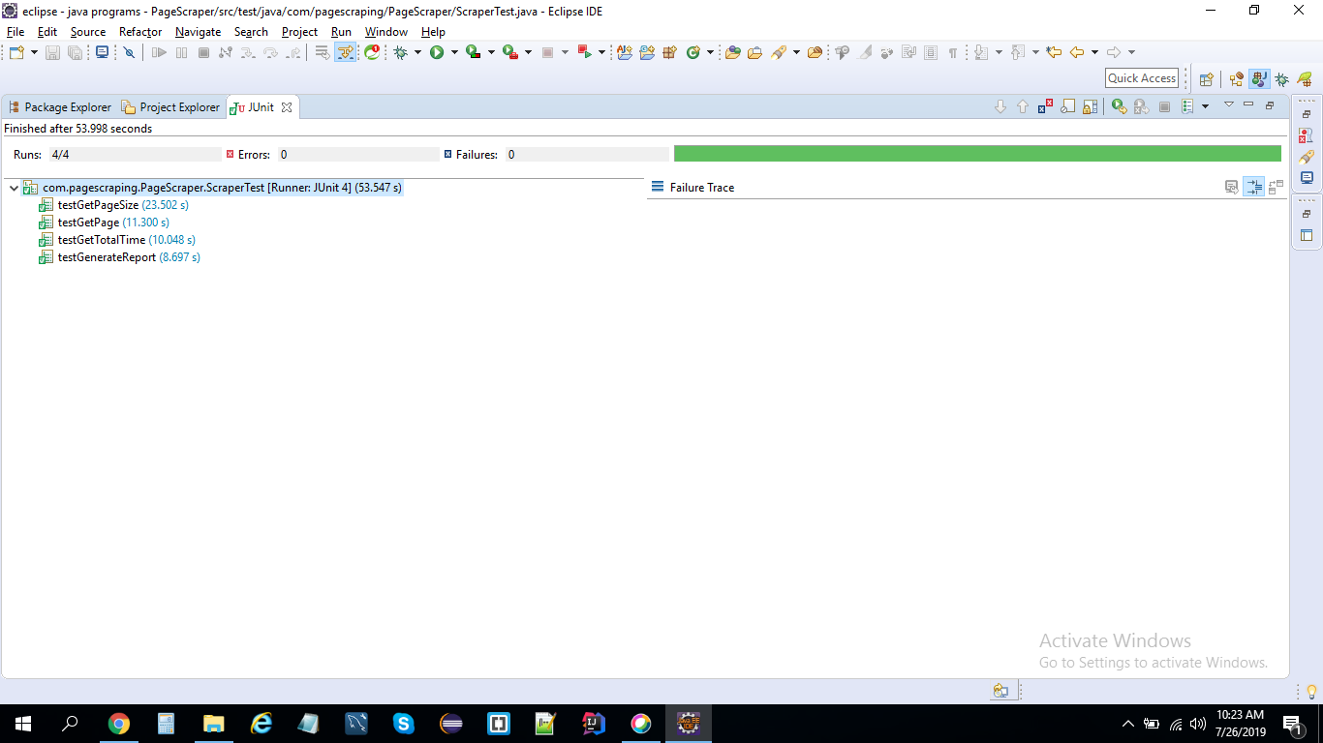

1. Generated report in Console:

